AWG Waveform Calibration using IQTools

This guide provides step-by-step instructions with screencaps for using a Keysight Oscilloscope or Spectrum Analyzer to calibrate out the phase/amplitude aberrations caused by the AWG itself and external fixturing using IQTools and Keysight’s Vector Signal Analysis (VSA) software.

This first revision of the instructions is for users intending to use modulated microwave carriers directly out of the AWG at frequencies between 1 and 25GHz. Later I will add baseband calibration methods.  
Note that the microwave calibration will work properly if baseband information is modulated with an external mixer, the Cal process is the same.

Note that while using IQTools, if the user hovers the pointer over buttons and sections of the GUI panels, detailed Tooltips will often appear. These are the only Help menus currently available for IQTools.

First, having all installed programs and licenses is necessary.

Some of these programs can be installed in other ways, but this is the preferred configuration, all installed and licensed on the AWG controller

1. The current version of the AWG software (M8190A or M8195A)
2. Matlab with all appropriate toolbox packages.  
     
   The toolbox packages are used by IQTools to create waveforms and interact with other instruments.  
   1. Keysight sells three packages with bundled Matlab toolboxs with the AWG instruments at a bundle discount.
   2. Our standard package necessary to create and run all applications is N6171A-M03 and includes

* MATLAB software environment
* Instrument Control Toolbox
* Communications System Toolbox
* DSP System Toolbox
* Signal Processing Toolbox

1. Keysight VSA with a minimum of these licenses
   1. Option 200 (Basic Vector Analysis)
   2. Option AYA (Vector Signal Analysis

VSA is used to analyze the waveform emerging from the AWG and/or fixturing, and create a multi-tap FIR filter that equalizes/removes the linear distortion.

1. Keysight IO Libraries
   1. This is a “universal interface and translator” program that interconnects Keysight/s hardware instruments to all the software pacakges.
   2. Essentially the software wants to talk to IO Libraries and IO Libraries talks to the instruments

Step 1 = Get the AWG Running and identify the connectivity addresses.

For the M8190A

Run the main software-server by activating this icon

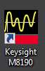

You will see this Software Server panel, leave it running and note the addresses for the M8190A module(s).  
The best address to use is the HiSLIP address, as this is the fastest and lowest-overhead method of communicating with the module.

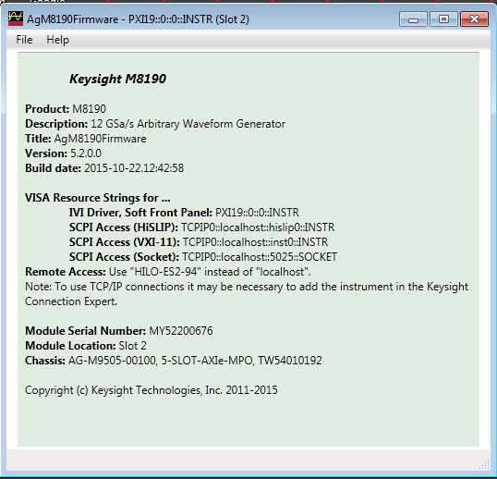

In this specific case the HiSLIP address is = TCPIP0::localhost:hislip0::INSTR

This will change depending on what slot the AWG is in the chassis and what other modules are present and when other addresses have already been consumed.’

A NOTE at this point about the M8195A software. The M8195A does not have a separate Software Server GUI, and therefore only one start-icon.

To find these important addresses for the M8195A, start the SFP and Server from the one icon and then look at Help > About from the menu pulldowns at the top of the M8195A SFP.

You will see this information GUI

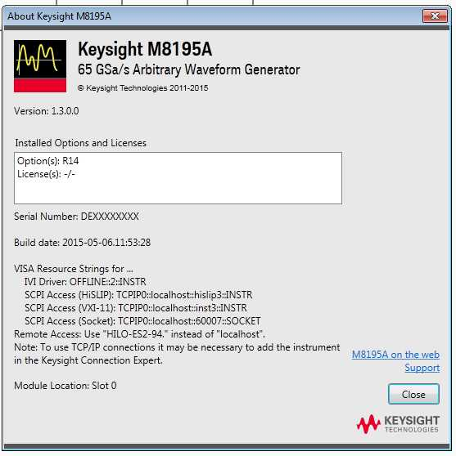

Note the same 4 odd looking addresses, including the HiSLIP address.

Now back to the M8195A example, as this is the only substantial difference in the starting methods between M8190A and M8195A.

Leave the server panel running, and activate the M8190A Soft Front Panel (SFP) with this icon.

C:\Users\nestwoo\Desktop\AWG  Caclibration for P\1 M8190A SFP Start.jpg

Note that it is not necessary to run the SFP in order to use IQTools, but it gives the user better visibility and control to have this Application running and accessible. Careful use of IQTools does allow the user to control all aspects of the AWG and external calibration receiver instrument.

You should see the SFP Application start to run as shown here with an instrument selection GUI

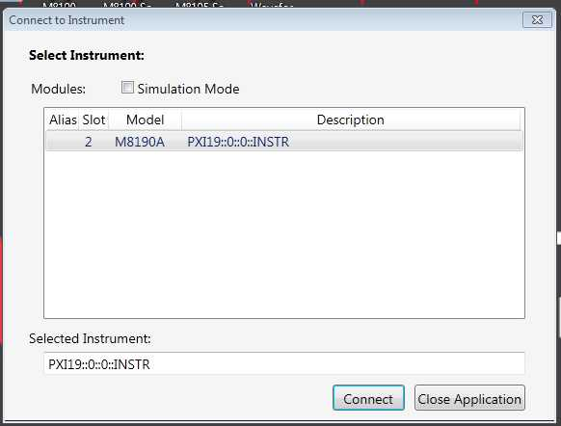

The odd looking address is a PXIe address, and in this case the M8190A is the only module in the chassis, so it is Zero. Select the AWG you wish to use and click Connect.

You should then see the controller communicating with the AWG via an “Access” light blinking. After the App boots up, you will see the Soft Front Panel (SFP) =

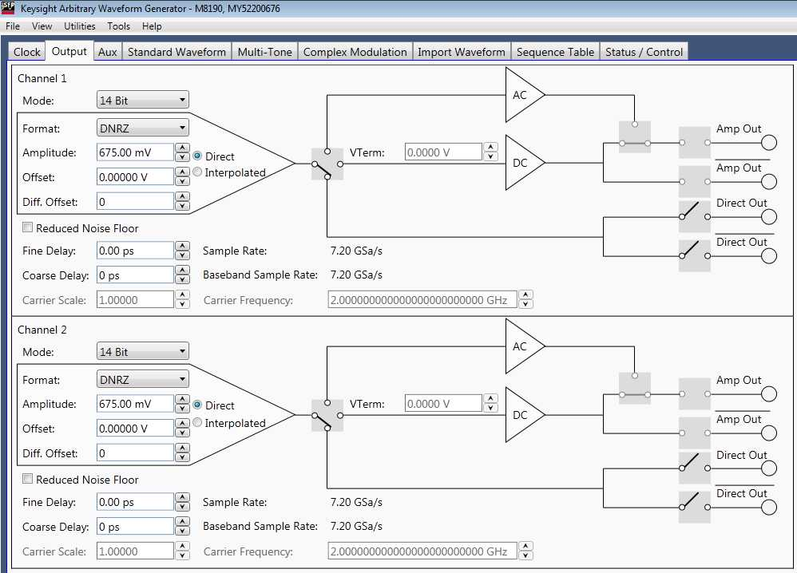

Here you can make whatever clock settings and connectivity settings and triggering settings for physical layer you wish. You can also see whatever IQTools has done here after you use IQTools to run the AWG.

NOTE that the IQTools Application will modify these settings as you choose in the IQTools App.

Do not use the SFP to create any waveforms. This will be done in IQTools, both for Calibration and for User-Waveforms.

The other useful functions of the SFP are Import Waveforms and Status Control and Trigger/Event Control as shown in these captures.

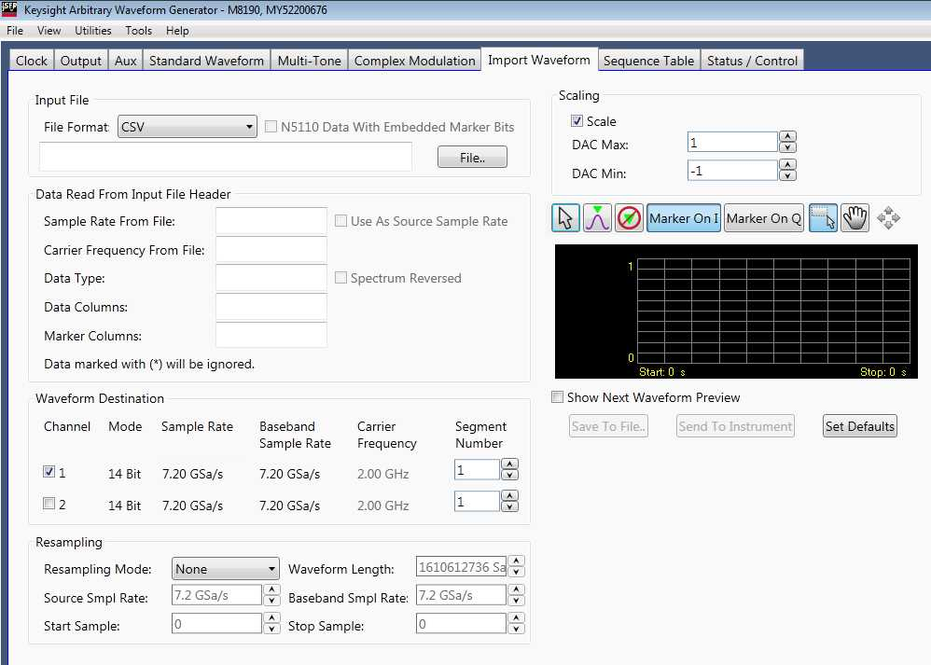

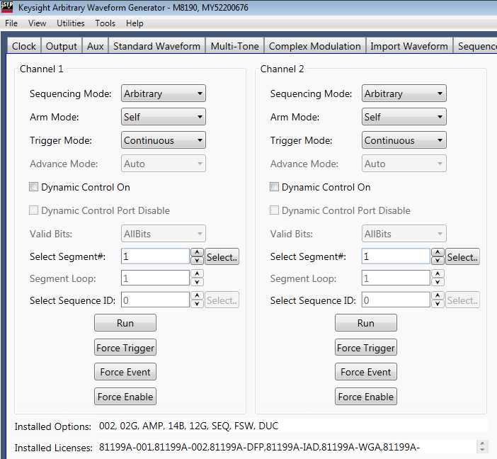



Now, we can start IQTools.

Since IQTools is simply an inter-related set of Matlab programs, you can do this in several ways.

Open Matlab and associated the path where you have stored IQTools folder of *.m files.  
This is required for all Matlab operations, and can be done from the “Set Path” folder-shaped icon in the Home menu-bar.  
Once the path with all IQTools *.m files is constructed, run “iqmain” from the command window prompt.

Here is an example of the Matlab environment showing iqmain being called from the Command window after the Path is established

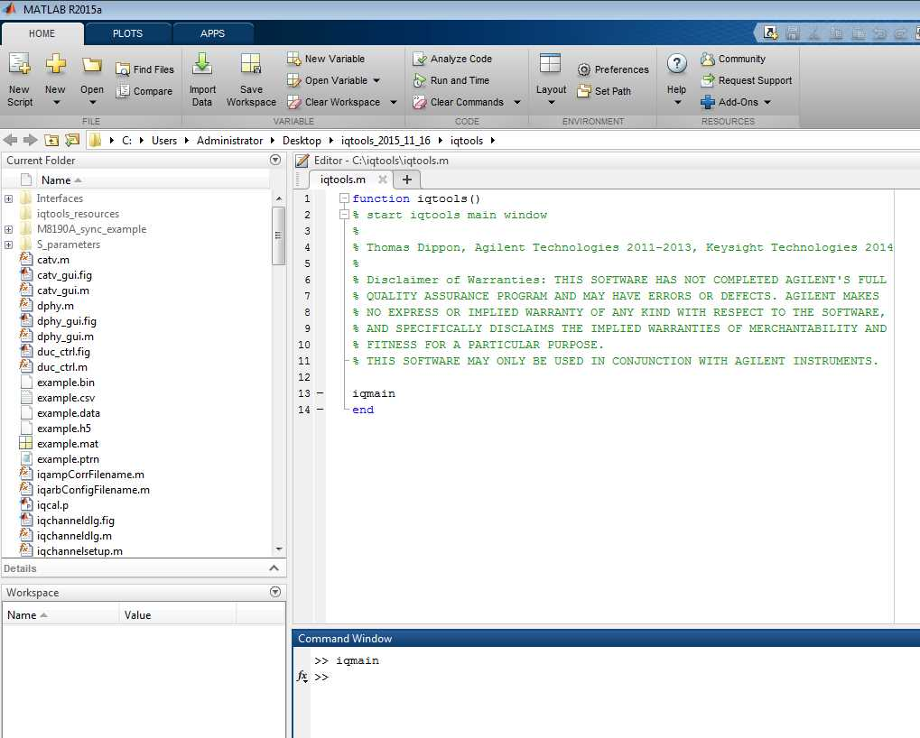

After starting the IQTools as shown above, you should see this primary IQTools Application panel, or some version of this, depending on what branch of IQTools you have operating. This is the latest IQTools main branch.

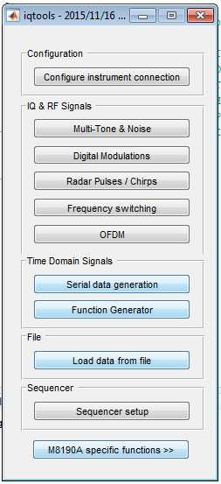

You can also place an IQMain shortcut on the desktop and Right-Click/Run from the icon. This is all standard Matlab operational methodology, nothing specific to IQTools.

Now we will connect the embedded PC running the M8190A/M8195A to an instrument to receive the waveform produced by the AWG and thereby provide measurement information back to IQTools and VSA used to calibrate out the AWG and fixturing.

Three instrument types are currently supported by IQTools as a receiver

* A Keysight Spectrum Analyzer, noting that the Instantaneous Bandwidth (IBW) of the calibration process is limited to the BW of the ADC installed in the Spectrum Analyzer. Typical analyzers are the MXA or PXA series, which have a maximum BW of 160 MHz, and the Keysight UXA which has a maximum analysis BW of 510 MHz  
  So, the maximum carrier frequency is the maximum frequency of the Spectrum Analyzer and the maximum IBW of the waveform calibration is the bandwidth of the ADC installed in the Spectrum Analyzer.
* A Keysight Windows-operating system Oscilloscope, such as the S-Series, V-Series or Z-Series scopes. In this case the IBW and the maximum frequency are idealistically the same. They are both the maximum frequency rating of the Scope.  
  However, practically speaking, a calibration of greater than 4 GHz IBW requires much more careful settings and setup than 1 or 2 GHz IBW.
* A Keysight Digital Communication Analyzer (DCA) type of “Sampling Scope”. While all of Keysight’s Scopes sample the incoming waveform, the sampling rate of the DCA is far slower than the S/V/Z-Series “Real-time” Scopes. The sampling rate of a Real-time scope is usually measured in GHz, whereas the sampling rate of the DCA is measured in KHz. Therefore, the DCA relies on having the calibration waveform repeat many times so that all points desired in the waveform are sampled. This is the normal operation of all DCA instruments, and the IQTools calibration Application takes this into account when running.  
  The IBW of the DCA is dependent on the plug-in module being used and can be as high as 70GHz for normal operation and possibly up to 110GHz with a software adjustment by contacting Keysight for guidance.
* Notes on differences in the receiver instruments being used.
  + The Spectrum Analyzer provides a balance of Microwave Frequency to IBW at the most reasonable price, and also has the highest-fidelity (number of bits) ADC. 14 Bits. However, it does have narrow IBW limitations.
  + The Real-time Scopes have very high IBW and can have very high Microwave frequency coverage, however each series has limitations. The scopes can actually be used above 50GHz carrier frequency, up to 63GHz.  
    - The S-Class scopes have 10 Bit ADC’s and low-noise front-end amplifiers to provide the best possible wideband internal noise. However, as with all wideband receivers, total noise power will limit the Signal/Noise (S/N) of the measured waveform, thereby limiting the accuracy of the calibration. Note that there is an option for the S/V/Z-Series scopes that will allow construction of internal FIR filtering prior to waveform measurement, thereby improving the S/N and the calibration. This requires a purchased option and support from a Keysight technical staff to construct.
    - The V-Series scopes also have low-noise amplification as with the S-Series, however they have an 8-Bit ADC. Somewhat reducing the accuracy of the Calibration.
    - The Z-Series scopes have a more normal Scope front-end process, meaning they have higher-noise amplification, and like the V-Series they have an 8-Bit ADC.
  + The DCA offers very low-cost upper microwave-frequency coverage, but has much higher input noise than the Spectrum Analyzer or Real-time Oscilloscope. Please consult with Keysight staff if you plan to use a DCA for calibration for advice.

So, now we select the “Configure Instrument Connection” Utility from the main IQTools Application.

You will see the Instrument Configuration Panel. For this first view, we see the pull-down selection of which AWG you are intending to work with.

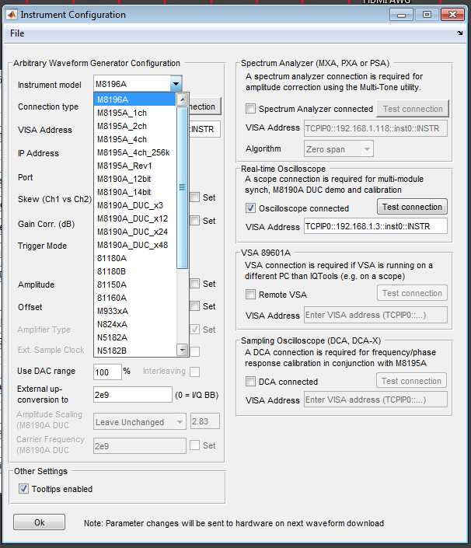

Be sure to select the AWG model and mode of operation, such as 12-Bit or 14-Bit for an M8190A and other options that match your desired operational configuration, otherwise the Calibration will either not operate or will not produce a usable calibration file.

Now we will proceed with the settings for all addressing and physical settings for one possible Calibration scenario.  
NOTE that this is where IQTools can and will over-ride any settings you made in the SFP for the module. There are many settings possible with this Instrument Configuration panel, so here some of the most important settings for this session are highlighted. Note that the “Set” check-boxes can override prior user-settings every time a waveform is downloaded.

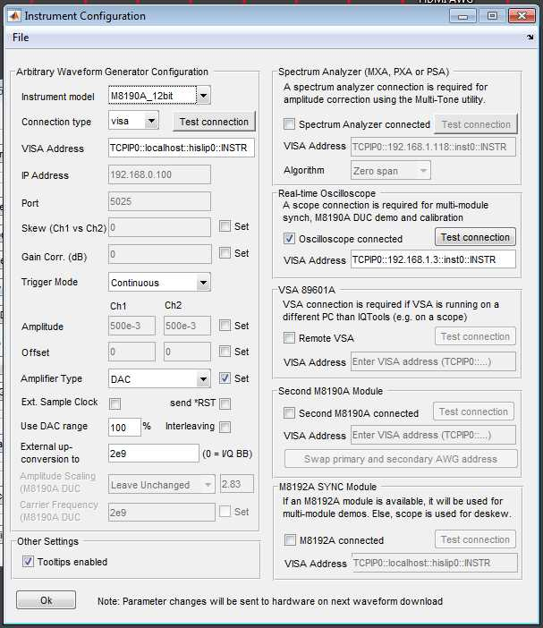

Here we will be configuring

* A Spectrum Analyzer, the UXA series with 510 MHz of IBW.
* And the 12-Bit mode of operation of the M8190A
* For Calibration we must use Continuous Trigger mode of operation.
* Now choose which output you wish to use
  + DAC (Direct Output)
  + AC (Microwave Amplified,
  + DC (DC Coupled Amplified)
  + Note that the amplified outputs will have less fidelity than the direct/DAC output, and that for this example we are selecting the DAC direct output

Finally in the main settings of this panel, you can choose to apply the Digital Upconversion (DUC) if you have this M8190A Option. This Digitally upconverts to a user-selected RF/Microwave frequency you wish to use for higher fidelity at a lower effective consumption of the stored waveform, thereby allowing more effective use of waveform-memory. This happens to be shown as 2GHz DUC here in the snapshot. For the remainder of this manual, we will use Microwave modulation methods instead of DUC.

More commonly put in “0” (Zero) for a Baseband DC-Coupled output and use the waveform creation tools later on in IQTools to construct a modulated carrier.

Now we will move on to the Address settings.

First to insure that the external instrument can be connected, open Connection Expert (part of IO Libraries). Here we see the latest version of Connection Expert showing the actual scenario for this example with an M8190A.

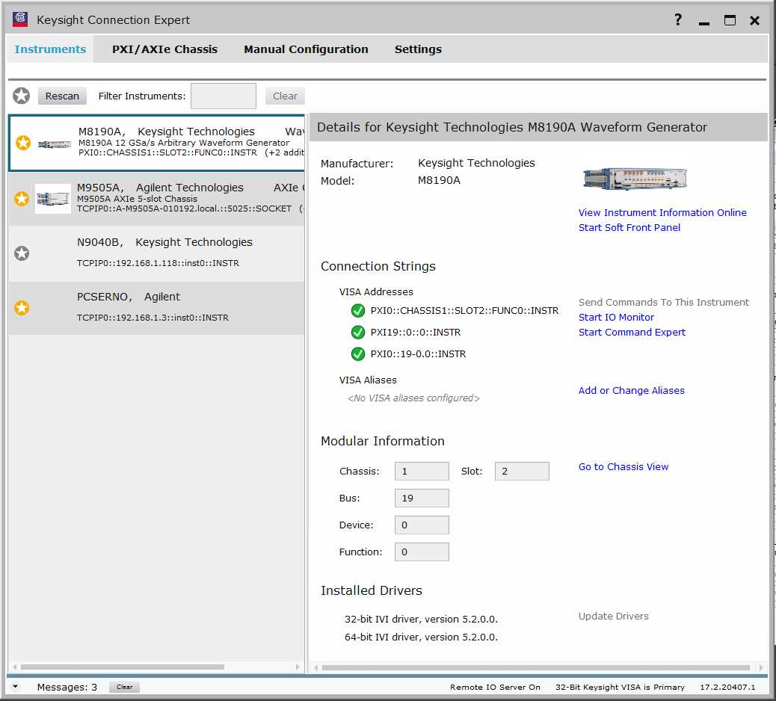

Perform a “ReScan” to make sure all connections that are easily obtained are found.

For this example, we have a Keysight UXA connected via a LAN connection.  
A LAN connection is the easiest method if available.  
In this case the UXA has an IP Address of 192.168.1.118.

In this snapshot case, we see

* An M8190A, the AWG for this example
* An M9505A, the 5-Slot AXIe chassis hosting the AWG and the Embedded Controller
* An N9405A, which is a UXA Spectrum Analyzer pre-configured for this example.  
  We will cover this connection shortly.
* A “PCSERNO, Agilent.” This is the Embedded controller itself.
* HOWEVER, if this is the first time you are connecting an external instrument you will NOT see the instrument available after the ReScan.

So, now we will go through connecting the Spectrum Analyzer for the first time. After the Analyzer is connected, it should automatically reconnect going forward.

First, be sure the LAN settings on the Embedded Controller allow connection to the Spectrum Analyzer.

Because the Embedded Controller has 3 LAN connections, it can be difficult to tell which one you have the external instrument connected to.

Do not use the LAN with this label “IOIOI’. This is a Serial Communication port, not a LAN port.

There will be LAN Connections showing in the Network and Sharing Center when nothing is connected to the Embedded Controller.

To find which LAN connection is live and attached to your measurement instrument, connect the live LAN cable and you will see this port added to the list of Access Type Connections.

As shown in this capture

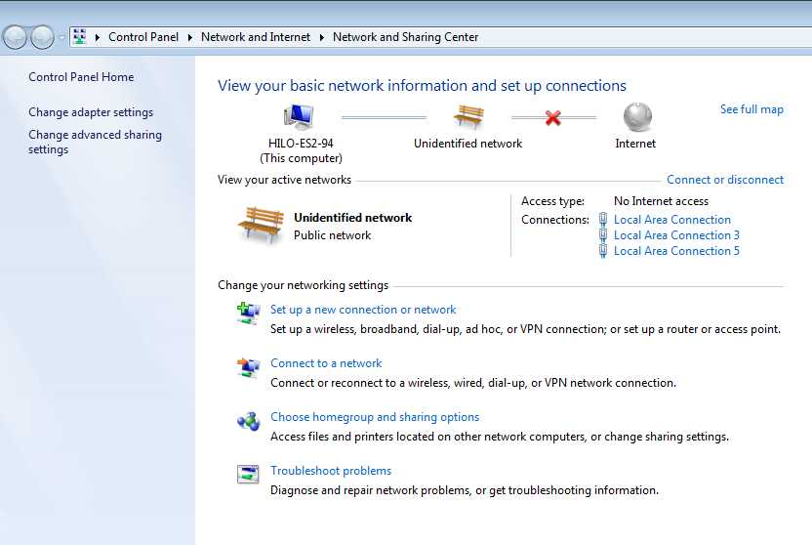

In this case, we will configure LAN Port #3 with an IP Address for the Port which is 192.168.1.100 and a Subnet Mask of 255.255.255.0 allowing all addresses up to 256 in this Subnet to be seen by the IPv4 protocol.

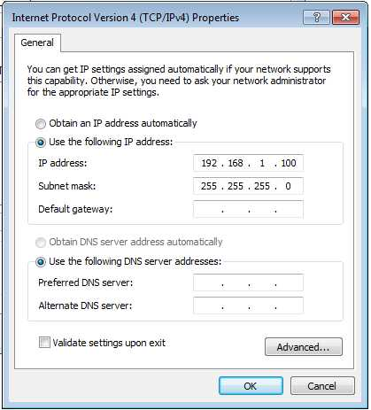

Ping the instrument IP address from the Embedded Controller to make sure connection is working. Ping your receiver instrument IP address from a Command Prompt on the Embedded Controller

Now we will add the IP address in Connection Expert so that the Spectrum Analyzer can be found/recognized.

In Connection Expert, go to Manual Configuration and type in the IP address as shown here.

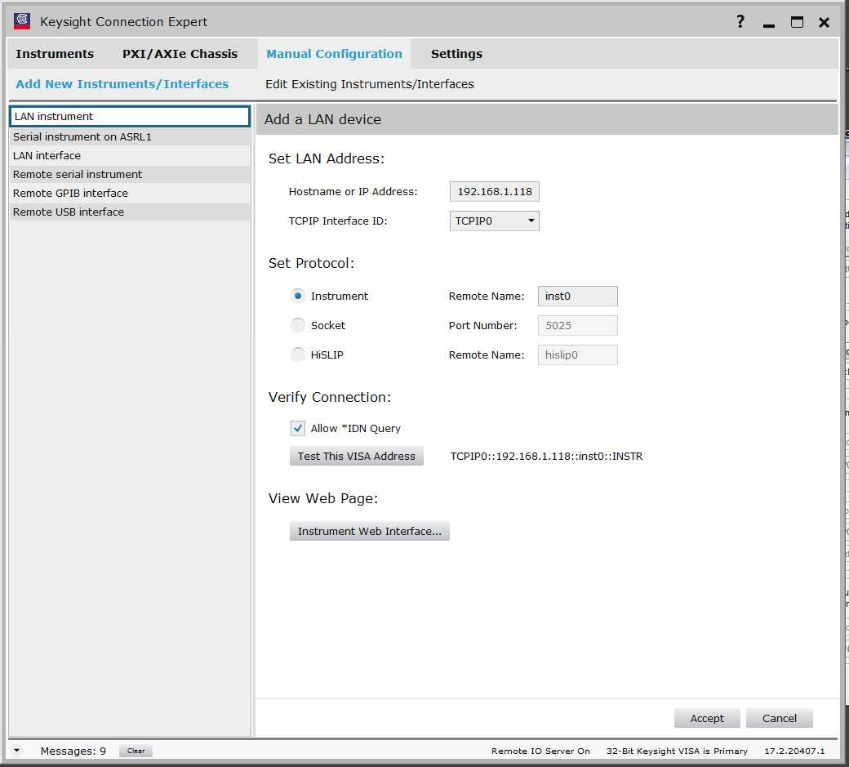

We use the IP address and TCPIP0 (that is a zero at the end). We can choose either Instrument or HiSLIP address here, shown is Instrument.

Do a “Test This VISA Address” to be sure the Spectrum Analyzer is connected.

You should see this type of response. It may be necessary to reboot the instrument if it has been used with another LAN connection recently.

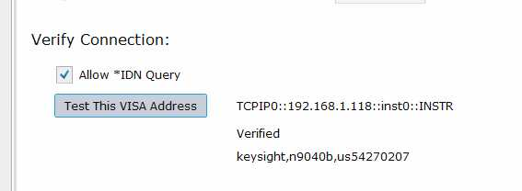

Now click on “Accept” and after a brief processing delay, you will be taken to the main Instruments panel in Connection Expert. The Receiver Instrument, in this case a Spectrum Analyzer will now show up in the panel as previously shown at the beginning of this guide.

Copy down the VISA Addresses showing for this instrument, in this case   
  
TCPIP0::192.168.1.118::inst0::INSTR.

Now that this basic IP setting is accomplished, we move to entering the external measurement instrument to the IQTools Instrument Configuration panel.

The external instrument address syntax is

TCPIP0::xxx.yyy.zzz.nnn::inst0.INSTR

Note this is TCPIP in all capital letters followed by a Zero.

Then two colons, and the IP address of the external instrument, followed by two colons.

Then inst0, which is inst and a Zero.

The INSTR in all capital letters.

This is entered as shown here

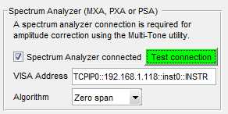

Click on Test Connection and you should see this button go **GREEN** to acknowledge that IQTools is communicating with the Spectrum Analyzer. If this fails, re-check the addressing scheme, including using a basic Ping.

Now go to the VISA Address for the AWG itself, and type in the HiSLIP address we found earlier during the AWG initialization process. In this case, it is

TCPIP0::localhost::hislip0::INSTR

Where the first portion is TCPIP0, the last digit is a Zero.

localhost is the address of the Embedded Controller itself

hislip0 is the internal HiSLIP address

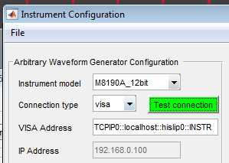

Click on the Test Connection and you should see this button go **GREEN** to acknowledge the IQTools is communicating with the AWG itself.  
Reminder – the settings in this panel will overwrite any you previously placed in and will be the settings used during the Calibration process. Therefore, the calibration will only be valid for these settings and ports.

Finally, click “OK” on the Configure Instrument panel and these settings will be loaded into IQTools. When we finish creating a Calibration Waveform, and download it during Calibration, all these settings will be applied.

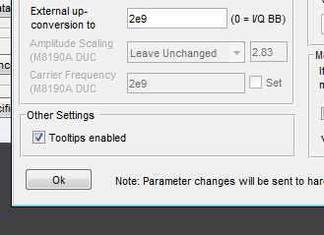

Now we go back to the primary IQTools panel and select the Digital Modulations Sub-panel

Some sidebar information on why we are using Digital Modulation to perform the calibration, regardless of what waveform you may be using. This is to insure the user chooses an appropriate Calibration waveform.

* The waveform itself is not what is being calibrated, it is the AWG and fixturing that is being characterized and removed. The method of Calibration assumes the signal analysis features and FIR Filter construction capability in VSA is being used. A good waveform that balances all these attributes and which covers the Amplitude and Phase excursions which will occur is QAM, specifically 16 QAM can be used. Other waveforms can also be used.
* The Calibration process constructs an FIR filter that can thereafter be applied to all waveforms, and at the end of the Calibration process this is automatically applied to the waveform and reloaded into the AWG to allow the user to check that the Cal is successful.
* Therefore, a Calibration waveform that exercises the user’s characteristics must be constructed. These are mainly
  + Center-frequency and span (IBW)
  + Phase-shift excursions
  + Amplitude-shift excursions.
* In this case, we are showing these characteristics
  + A center frequency of 2 GHz is entered “Carrier Offset”
  + A span of 400 MHz (IBW)
  + By applying 16QAM we cover almost all changes in Phase and Amplitude throughout the Bandwidth occupied by the user’s waveform.
  + We select QAM16 from the pulldown menu
  + We leave the default filter type and coefficients as-is.
  + We leave the data-source to Random to make sure no pattern-dependent artifacts occur.
  + No Quadrature or I or Gain imbalance distortion is applied.
  + And finally for this example I have entered Real/I to channel 1 and Imaginary/Q to Channel 2. The user is invited to change these settings to see how the waveforms can be directed, including this “Real” modulated channel only to Channel #1, which is what we will be connecting to the Spectrum Analyzer input.

You should see this Digital Modulations Sub-panel.

Be sure to put in the settings suitable for your Calibration, this screen-capture is not correct for many waveforms.

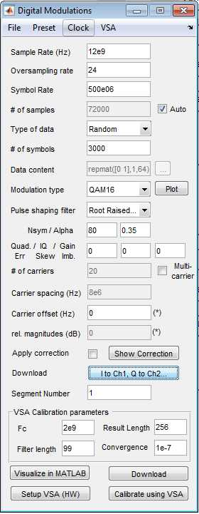

* Now the user can “Visualize in Matlab” which starts Matlab and creates two simple graphics. These are an easy sanity-check on the constructed waveform and can be used when the laboratory waveforms are being made.  
  + One is the Time-Domain waveform which should be created. For IQ Baseband waveforms this should appear to be the desired “Scope-Like” waveform.
  + For RF/Microwave modulated waveforms the Time Domain graph is meaningless and the IQ Spectrum Waveform should appear as the user desired to create.

Now you can Click “Download” in the Digital Modulations panel and you should see a 2GHz Center Frequency, 400 MHz Bandwidth waveform on the screen of the analyzer. It is possible to direct I and Q separately to each of the possible outputs of the module. The Download I/Q selection button will result in a Panel that allows this

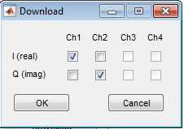

Now we make sure that VSA is analyzing the Calibration waveform.

We use the “Setup VSA (HW) button in the lower right side of the Digital Modulations Application.

This will launch a session of VSA and show the waveform being analyzed in a simple setup directed by IQTools.

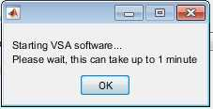

1. Note that the FIRST time VSA is connected, a prior instrument setup may be retained. This will prevent the data from being fed into the VSA software for demodulation and analysis.
2. To overcome this, use the following steps

You will see that “No Data” is indicated, so here are the steps to connect the new instrument to VSA

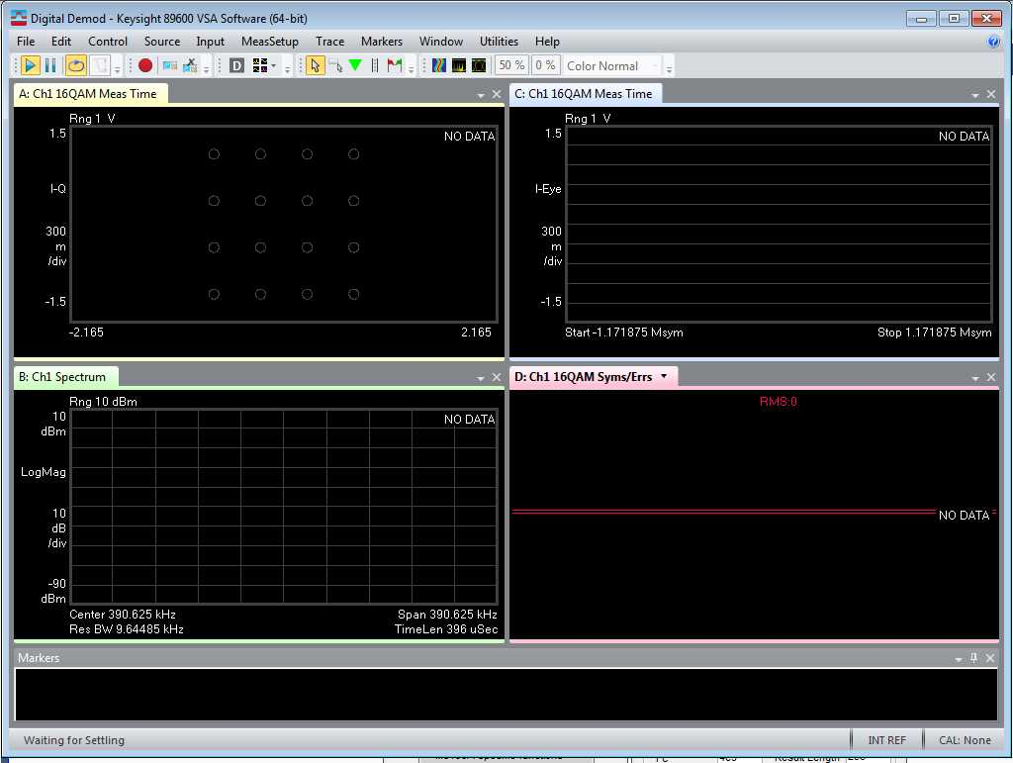

Another symptom is to select Utilities > Hardware > Configurations and you will see no Discovered receiver instrument. In this case, no Spectrum Analyzer.

To correct this and connect to the Receiver Instrument, use these steps.

Go into Utilities > Hardware > Discovered Instruments and find the TCPIO area here

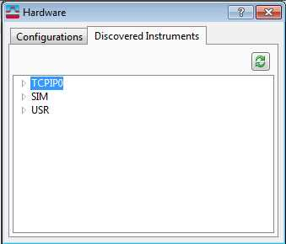

Click on the green dual-arrow icon in the upper Right-Hand corner and the VSA software will look in Connection Expert for the previously discovered Spectrum Analyzer.

You will see a panel similar to this, note that the 192.168.1.118 IP address has been found.

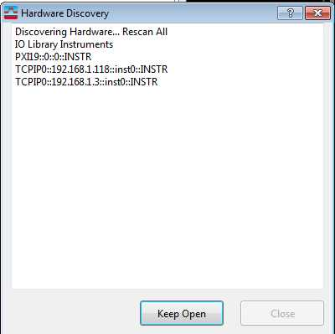

Now back in Configurations you will see a version like this, allowing you to select and ADD the Spectrum Analyzer with the “**+**” Sign button.

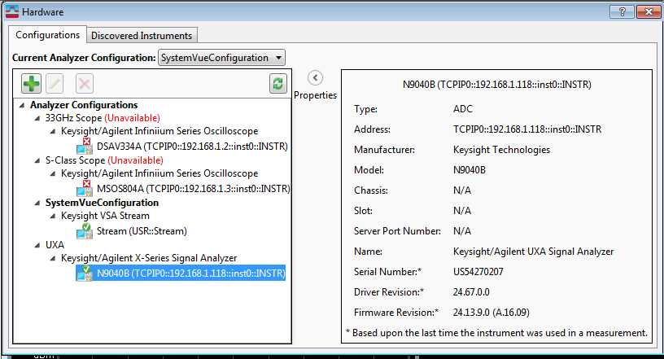

A menu like this will appear

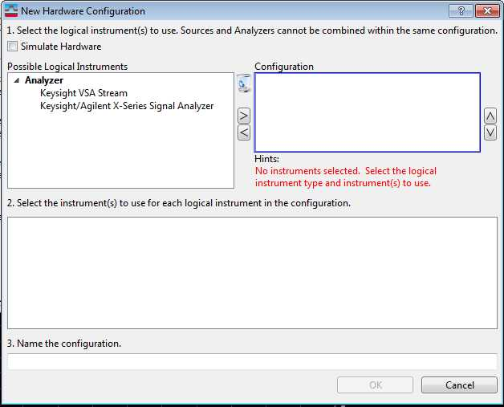

Use the Right/Left arrows after selecting the Spectrum Analyzer from the available menus (the VSA Stream is a specialized element which can get the data from a file or recording device). The result should look like this

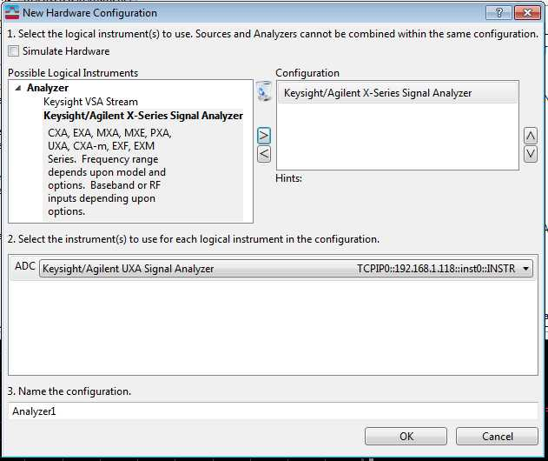

Now click OK and go back to the VSA Main Application, and to the Utilities > Hardware > Signal Analyzer selection from the pull-down menus. The result should look like this

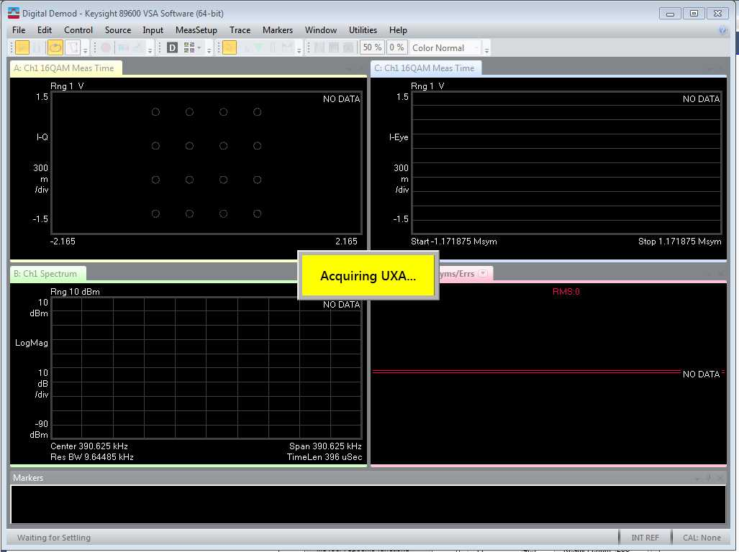

And once VSA has acquired the Spectrum Analyzer the screen looks similar to this

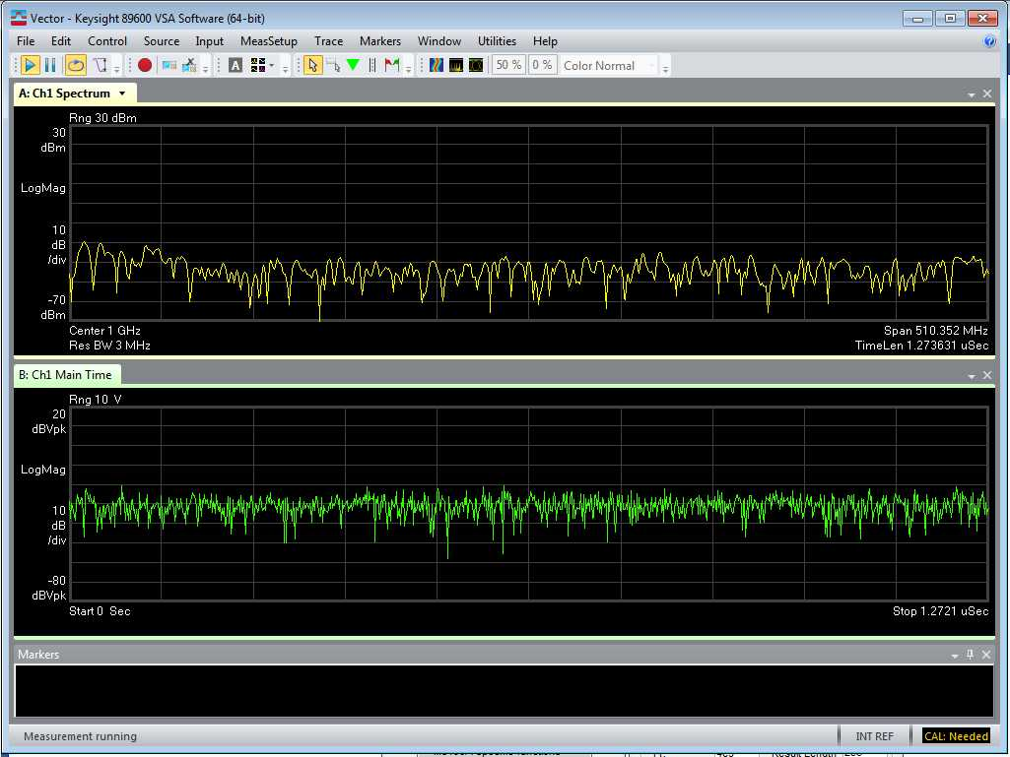

Now that the hardware is connected to VSA, you can close this stub-session and re-try “Setup VSA (HW) from the IQTools waveform creation panel. You should see a VSA session like this

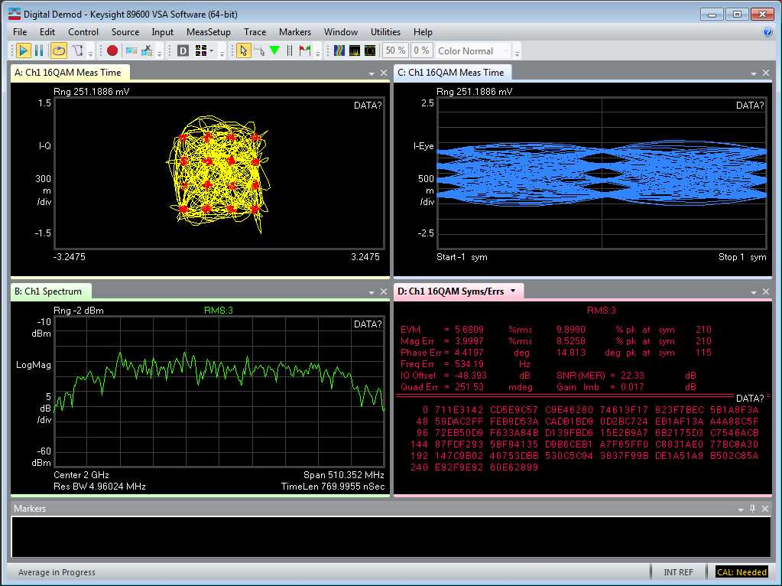

This confirms that the VSA and hardware and waveform are all operating together.

Note that the 16 QAM constellation menu in the upper left is not very good, the red-dots are disorganized and variable. The EVM number in the lower-right panel is around 5% which is not very good for a 16QAM signal from the AWG. These are symptoms of the phase/amplitude distortion in the AWG and fixturing of this guide setup.

CLOSE THE VSA SESSION and proceed.

Finally, we have reached the fully automated Calibration process.  
The final button in the lower right-hand corner of the Digital Modulations panel is “Calibrate Using VSA.

Click on the “Calibrate Using VSA” and these steps should occur

1. VSA will launch, after a 1 – 3 minute processing wait.  
   Once VSA is launched, it may be minimized into the tray below, or not. However, you will see a sub-panel like this, indicating the Calibration process is operating. This menu is where you will finalize the Calibration process and store the Calibration File into the Embedded Controller.  
   Do not try to change the Spectrum Analyzer or Scope settings while VSA has control, as this will de-synchronize the communications between VSA and IQTools and the hardware, which can potentially require a complete reboot of the equipment.

Instead, use this sub-panel to either complete the Calibration session or Cancel the session.

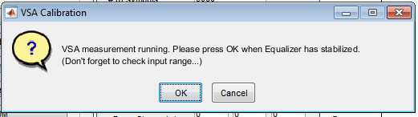

1. A more complex VSA Panel containing the full FIR filter construction systems will appear.  
   The user should see a replica of the “Setup VSA (HW) state with a fairly good constellation diagram. Only briefly. Then the automatic FIR Filter construction process begins and the right-hand Phase and Amplitude correction diagrams begin to change. Often this will occur quite quickly for relatively narrowband (less than 2 GHz IBW) signals.

The added two analysis panels in VSA are the phase and amplitude FIR filter characteristics that have been established by the algorithm in VSA to maximize the performance displayed in the Constellation and minimize EVM results. This can be seen as a dramatic improvement in Constellation coherence and a dramatic reduction in EVM metric, as see here.

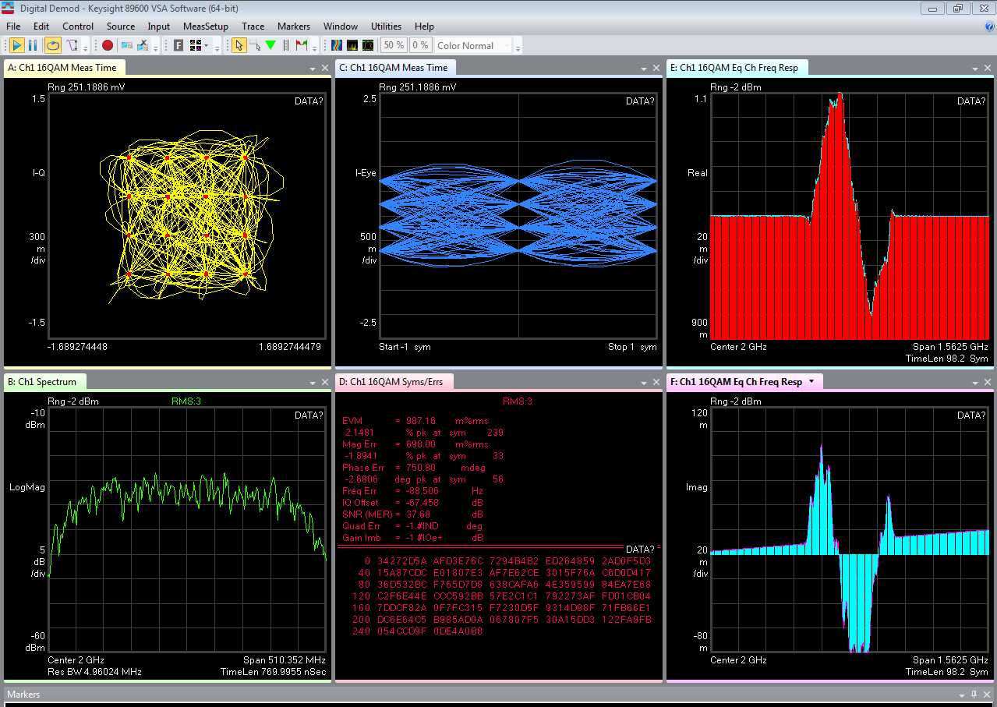

1. While this process is underway, the Spectrum Analyzer or Scope will have an odd-looking display because VSA has captured the instrument. This will return to normal once VSA is halted in IQTools.
2. Once the EVM number has stabilized and the Red/Blue correction graphs have stabilized, use the VSA Calibration panel to say “OK”, and IQTools will collect and process the resulting FIR Filter.
3. The 16 QAM waveform file is corrected using the FIR filter and the results are Calibrated waveforms with the phase/amplitude distortion removed.

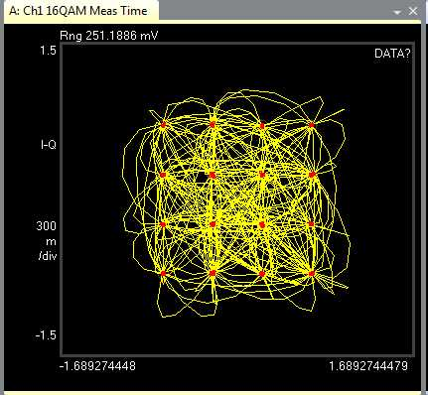 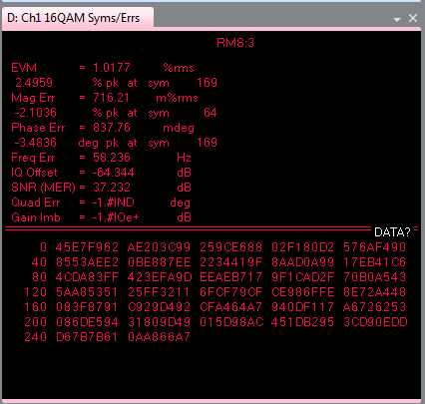

1. So, how do I use this to correct my created waveform you may ask?
2. Go back to the waveform creation sub-panel and you will see that the Apply Correction checkbox is now checked. Next to that box is a “Show Correction” button. Click on that button and you will find this GUI.

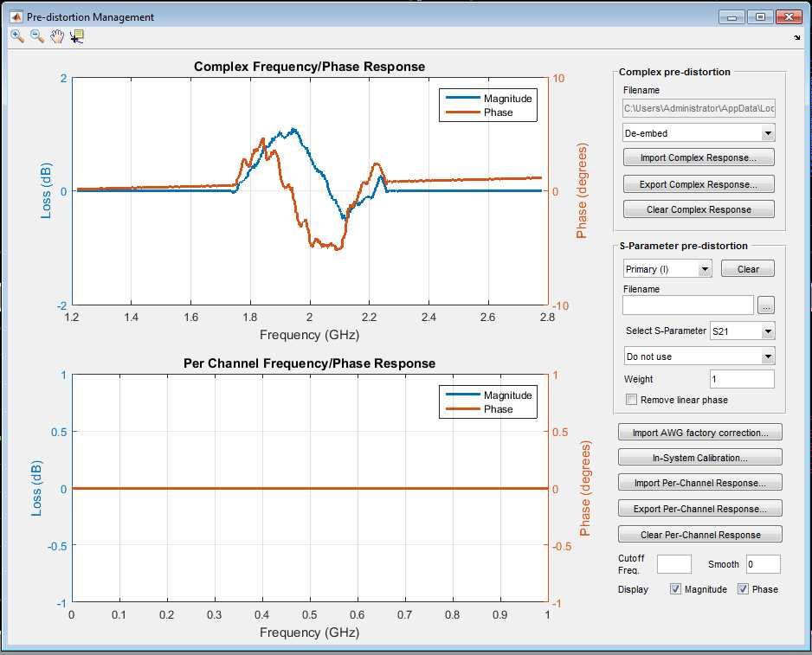

This is a panel showing the stored Magnitude and Phase Calibration Coefficients as a graph, and the user can note that ALL waveform creation and Waveform Import utilities have this Apply Correction check-box. The Calibration we have done can now be applied to all future waveforms as long as the center frequency of the stored waveforms is the same and the IBW is the same or smaller than the settings used during Calibration.

So, the user can now either use the other Waveform construction utilities in IQTools, or use the Load from File Sub-application to load an externally created waveform and apply Calibration and/or “Frequency Offset” if the waveform is a Baseband construction. This is simply the center-frequency which is being modulated with the user’s baseband waveform.

This Load from File GUI illustrates the available formats and settings that can be applied to a user-created waveform. Note that it is very important to have the correct file-format and Sample-rate and File Size which matches the binary size of the data-bus feeding the DAC in the AWG. Such as 12 Bit, 14 Bit or 8 Bit as appropriate. Re-sample data can be used, but some degradation of the waveform quality will occur.

Note the “Apply Correction” checkbox can be applied here to the ideal waveform and the calibration will be applied to remove AWG and Fixturing distortion.

